 |  | 
Faculty of Technology and Engineering
Chandubhai S. Patel Institute of Technology (CSPIT)
Department of Computer Science & Engineering
Date: 24/09/2026
Laboratory Manual
Academic Year | : | 2026-27 | Semester | : | 3rd
Course code | : | ITUE203 | Course name | : | WEB DEVELOPMENT FRAMEWORKS

Practical – 7
PHP Form Processing with Server-Side Validation and CSV/JSON File Storage

Problem Statement:- Process submitted registration/contact form data using PHP. Validate and sanitize inputs on the server side and store records in CSV or JSON file
format. Display success/error messages.

Objective:- To develop a PHP-based server-side form processing system that validates and sanitizes user inputs, securely stores submitted registration/contact data in CSV or JSON format, and displays appropriate success or error messages.

Github Repository Link:- https://github.com/Nishtha-cse/StudentHubPortal-D26CS129

index.php :
<?php
session_start();

$errors = $_SESSION['errors'] ?? [];
$oldData = $_SESSION['old_data'] ?? [];
$success = $_SESSION['success'] ?? '';

unset($_SESSION['errors'], $_SESSION['old_data'], $_SESSION['success']);

function old(array $data, string $key): string {
return htmlspecialchars($data[$key] ?? '', ENT_QUOTES, 'UTF-8');
}
?>
<!DOCTYPE html>
<html lang="en">
<head>
<meta charset="UTF-8">
<meta name="viewport" content="width=device-width, initial-scale=1">
<title>Registration</title>

<link rel="preconnect" href="https://fonts.googleapis.com">
<link rel="preconnect" href="https://fonts.gstatic.com" crossorigin>
<link href="https://fonts.googleapis.com/css2?family=DM+Sans:wght@400;500;600;700&display=swap" rel="stylesheet">
<link rel="stylesheet" href="style.css">
</head>
<body>
<main class="form-card">
<h1>Create your registration</h1>
<p class="intro">Fill in your details below. All fields are required.</p>

<?php if ($success): ?>
<div class="alert success">
<?= htmlspecialchars($success) ?>
</div>
<?php endif; ?>

<?php if ($errors): ?>
<div class="alert error" role="alert">
<strong>⚠ Please correct the following errors:</strong>
<ul>
<?php foreach ($errors as $error): ?>
<li><?= htmlspecialchars($error) ?></li>
<?php endforeach; ?>
</ul>
</div>
<?php endif; ?>

<!-- novalidate lets the server-side errors above appear instead of browser popups -->
<form action="process.php" method="POST" novalidate>
<div class="form-grid">

<div class="field">
<label for="name">Name</label>
<input type="text" id="name" name="name" autocomplete="name"
value="<?= old($oldData, 'name') ?>">
</div>

<div class="field">
<label for="email">Email</label>
<input type="email" id="email" name="email" autocomplete="email"
value="<?= old($oldData, 'email') ?>">
</div>

<div class="field">
<label for="mobile">Mobile</label>
<input type="text" id="mobile" name="mobile" inputmode="numeric"
maxlength="10" autocomplete="tel-national"
value="<?= old($oldData, 'mobile') ?>">
</div>

<div class="field">
<label for="pincode">Pincode</label>
<input type="text" id="pincode" name="pincode" inputmode="numeric"
maxlength="6" autocomplete="postal-code"
value="<?= old($oldData, 'pincode') ?>">
</div>

<fieldset class="field full">
<legend>Gender</legend>
<div class="radio-row">
<input type="radio" id="male" name="gender" value="male"
<?= ($oldData['gender'] ?? '') === 'male' ? 'checked' : '' ?>>
<label for="male">Male</label>

<input type="radio" id="female" name="gender" value="female"
<?= ($oldData['gender'] ?? '') === 'female' ? 'checked' : '' ?>>
<label for="female">Female</label>
</div>
</fieldset>

<div class="field full">
<label for="address">Address</label>
<input type="text" id="address" name="address" autocomplete="street-address"
value="<?= old($oldData, 'address') ?>">
</div>

<div class="field full">
<label for="message">Message</label>
<textarea id="message" name="message"><?= old($oldData, 'message') ?></textarea>
</div>

</div>

<div class="actions">
<button type="submit">Submit</button>
</div>
</form>
</main>
</body>
</html>

Process.php :

<?php
session_start();

if ($_SERVER['REQUEST_METHOD'] !== 'POST') {
header('Location: index.php');
exit();
}

$storage_mode = 'json'; // 'json' or 'csv'

/* ---------- Read input ---------- */
$name = trim($_POST['name'] ?? '');
$email = trim($_POST['email'] ?? '');
$mobile = trim($_POST['mobile'] ?? '');
$pincode = trim($_POST['pincode'] ?? '');
$gender = trim($_POST['gender'] ?? '');
$address = trim($_POST['address'] ?? '');
$message = trim($_POST['message'] ?? '');

// Kept so the form can be refilled if validation fails
$oldData = compact('name', 'email', 'mobile', 'pincode', 'gender', 'address', 'message');

/* ---------- Validate ---------- */
$errors = [];

if ($name === '') {
$errors[] = 'Name is required.';
} elseif (!preg_match('/^[a-zA-Z ]{2,50}$/', $name)) {
$errors[] = 'Name must contain only letters and spaces.';
}

if ($email === '') {
$errors[] = 'Email address is required.';
} elseif (!filter_var($email, FILTER_VALIDATE_EMAIL)) {
$errors[] = 'Enter a valid email address.';
}

if ($mobile === '') {
$errors[] = 'Mobile number is required.';
} elseif (!preg_match('/^[0-9]{10}$/', $mobile)) {
$errors[] = 'Mobile number must contain exactly 10 digits.';
}

if ($pincode === '') {
$errors[] = 'Pincode is required.';
} elseif (!preg_match('/^[0-9]{6}$/', $pincode)) {
$errors[] = 'Pincode must contain exactly 6 digits.';
}

if (!in_array($gender, ['male', 'female'], true)) {
$errors[] = 'Please select a valid gender.';
}

if ($address === '') {
$errors[] = 'Address is required.';
}

if ($message === '') {
$errors[] = 'Message is required.';
}

if ($errors) {
$_SESSION['errors'] = $errors;
$_SESSION['old_data'] = $oldData;
header('Location: index.php');
exit();
}

/* ---------- Sanitize ---------- */
$entry = [
'timestamp' => date('Y-m-d H:i:s'),
'name' => htmlspecialchars($name, ENT_QUOTES, 'UTF-8'),
'email' => htmlspecialchars($email, ENT_QUOTES, 'UTF-8'),
'mobile' => htmlspecialchars($mobile, ENT_QUOTES, 'UTF-8'),
'pincode' => htmlspecialchars($pincode, ENT_QUOTES, 'UTF-8'),
'gender' => htmlspecialchars($gender, ENT_QUOTES, 'UTF-8'),
'address' => htmlspecialchars($address, ENT_QUOTES, 'UTF-8'),
'message' => htmlspecialchars($message, ENT_QUOTES, 'UTF-8'),
];

/* ---------- Store ---------- */
function saveToCSV(string $file, array $entry): bool
{
$isNew = !file_exists($file);
$handle = fopen($file, 'a');
if (!$handle || !flock($handle, LOCK_EX)) {
return false;
}
if ($isNew) {
fputcsv($handle, array_keys($entry));
}
fputcsv($handle, array_values($entry));
flock($handle, LOCK_UN);
fclose($handle);
return true;
}

function saveToJSON(string $file, array $entry): bool
{
$records = file_exists($file) ? json_decode(file_get_contents($file), true) : [];
if (!is_array($records)) {
$records = [];
}
$records[] = $entry;
return file_put_contents($file, json_encode($records, JSON_PRETTY_PRINT), LOCK_EX) !== false;
}

if ($storage_mode === 'csv') {
$saved = saveToCSV('data.csv', $entry);
$where = 'CSV';
} else {
$saved = saveToJSON('data.json', $entry);
$where = 'JSON';
}

if ($saved) {
$_SESSION['success'] = "Registration successful! Data stored in $where file.";
} else {
$_SESSION['errors'] = ['Unable to save registration.'];
$_SESSION['old_data'] = $oldData;
}

header('Location: index.php');
exit();

Registraition Form :

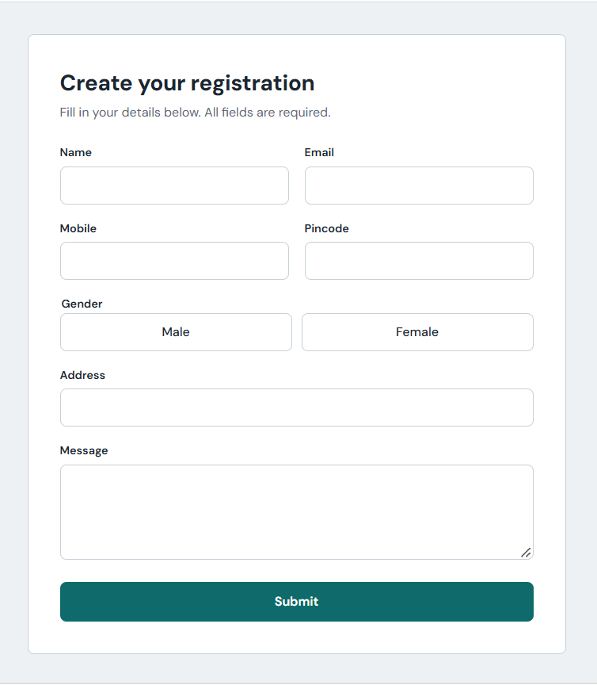

Required Field Validation :

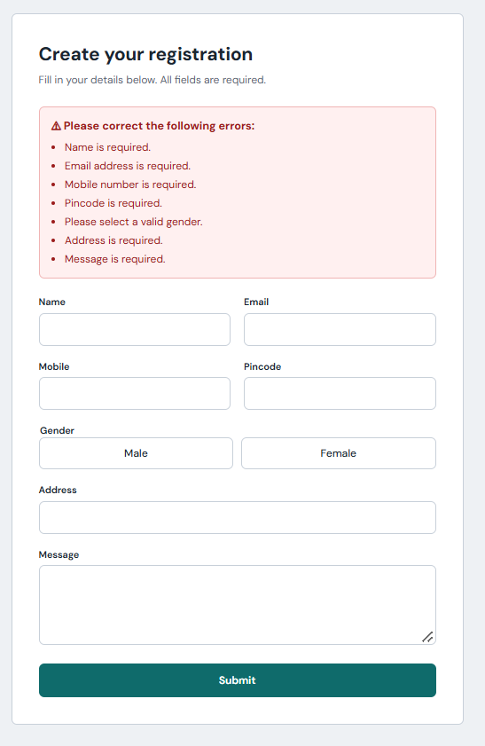

Name Format Validation :

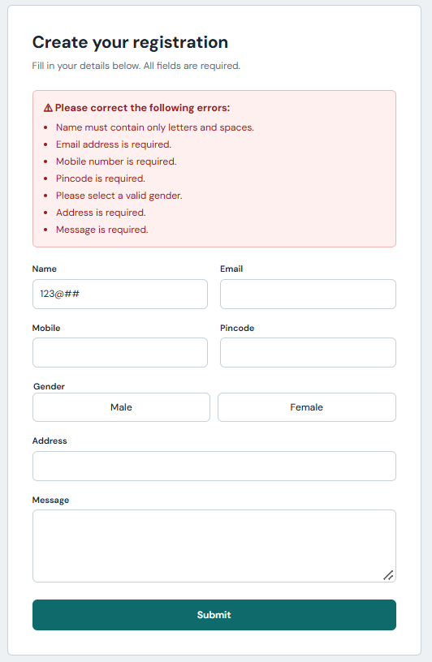

Email Format Validation :

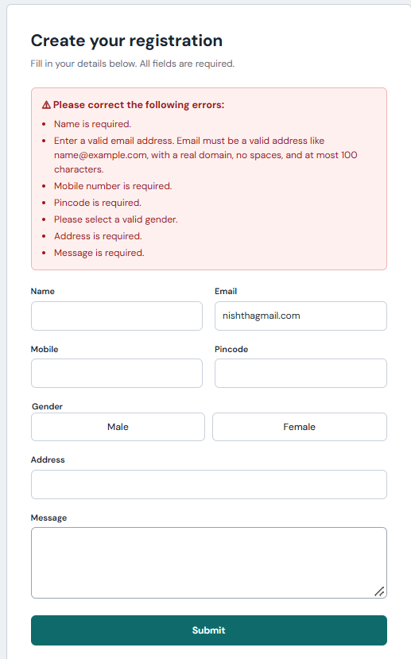

Mobile Number Format Validation :

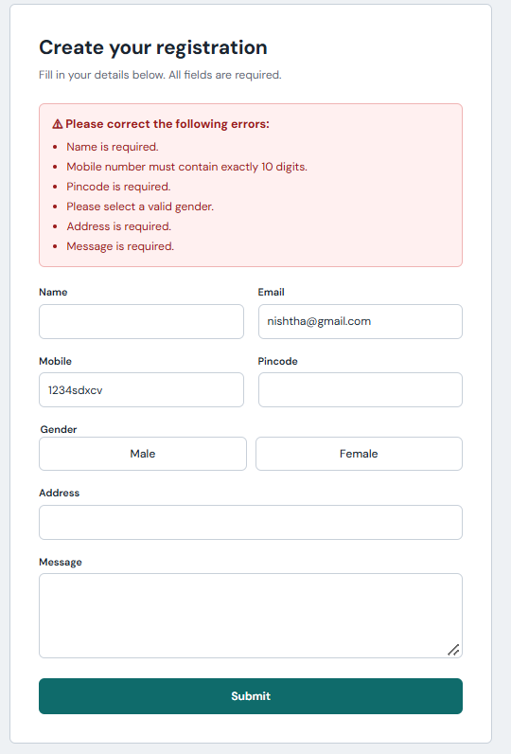

Gender Selection Validation:

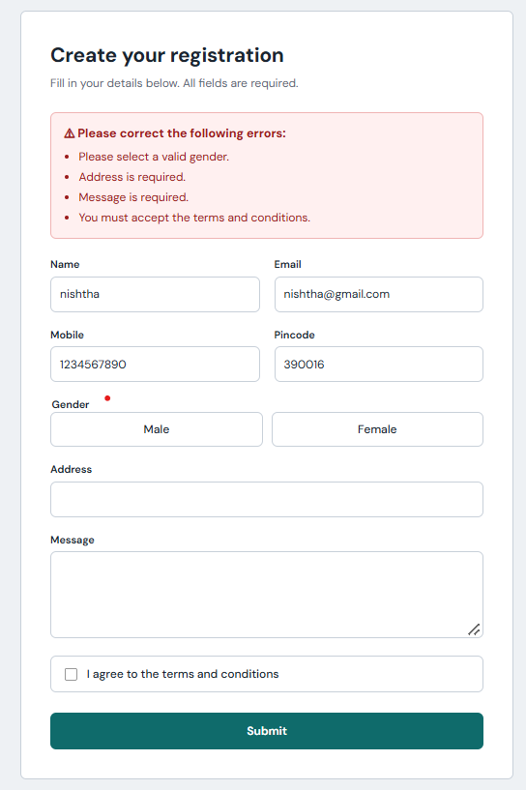

Terms & Conditions Validation :

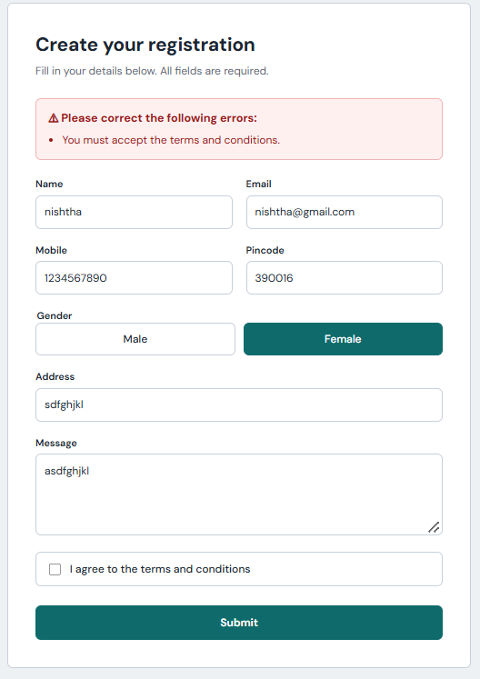

Registration Successful :

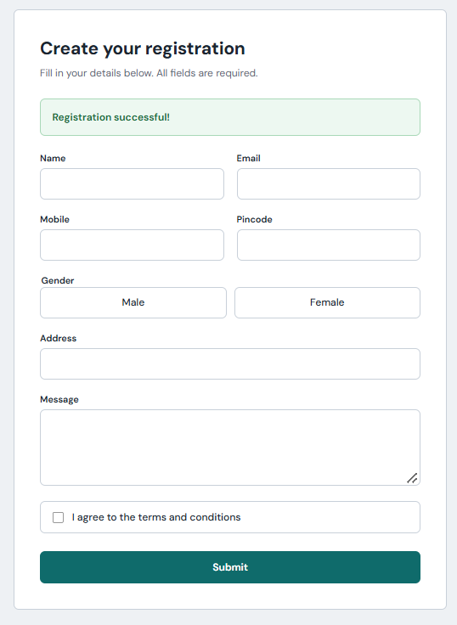

Data Stored in CSV File successfully :

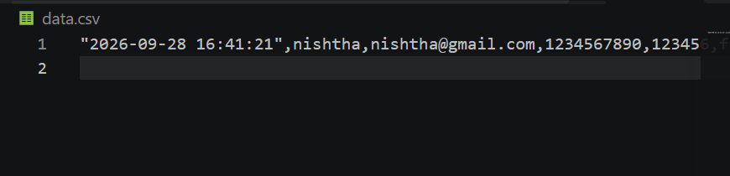

Data Stored in Json File successfully :

